Hawaii Light Bucket Astronomy Conference
December 31, 2010-January 2, 2011 / Mauna Kea Tour – December 29, 2010

Mauna Kea Tour / Gemini and NASA IRTF

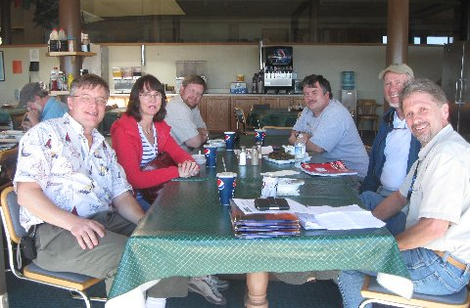

We stopped for lunch at the 9000 foot level at the "Mauna Kea Hotel." Peter Michaud from Gemini (far right) was our guide. Peter knows Gemini inside out, and provided fascinating historical insights. Thanks Peter for a first class tour!

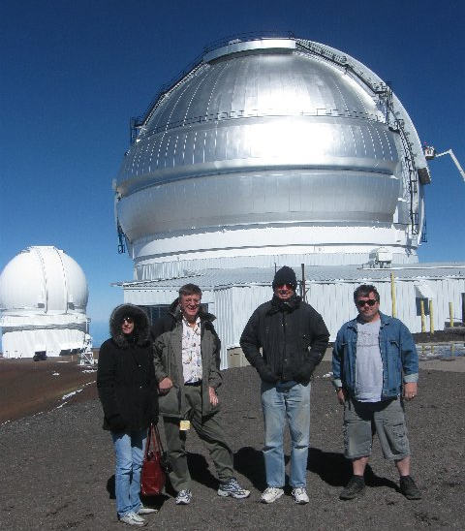

In front of Gemini. The Canada-France-Hawaii telescope is to the left. Denise, Bruce, Russ, & Chris.

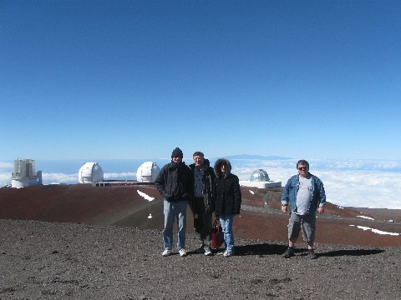

Subaru to the left, then Keck I and II, and then NASA IRTF.

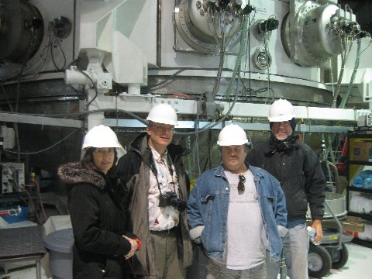

We started at the bottom level and worked our way up. The vacuum coating chamber is behind us. Just a bit larger than Drew's! They coat their mirror with silver for outstanding reflectivity and low IR emissivity.

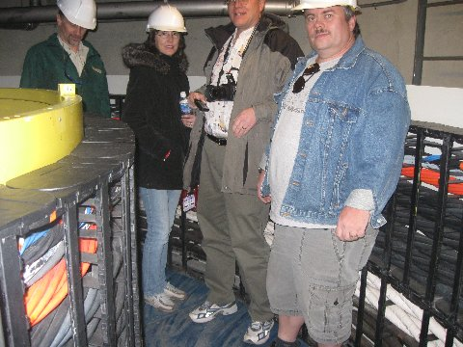

Up one level at the azimuth cable wrap. Gemini can make 1 1/2 revolutions without fouling up the cables. Motors keep the cables from dragging on the telescope.

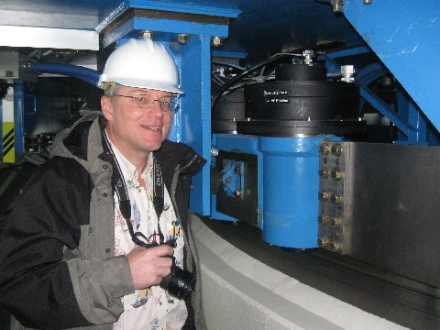

Bruce liked the Renishaw tape that allows 1 arc second pointing accuracy. The tape is below the spring plate mounted azimuth drive motor (one of several). This is a one stage friction drive system. High torque motors drive the azimuth disk directly.

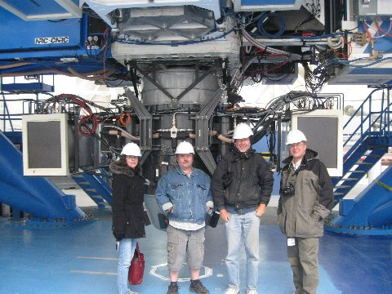

Cass focus instruments. Four instruments out to the sides, one straight through. Moving between instruments is very fast and computer controlled. This facilitates queue scheduling, which accounts for about 90% of Gemini observations.

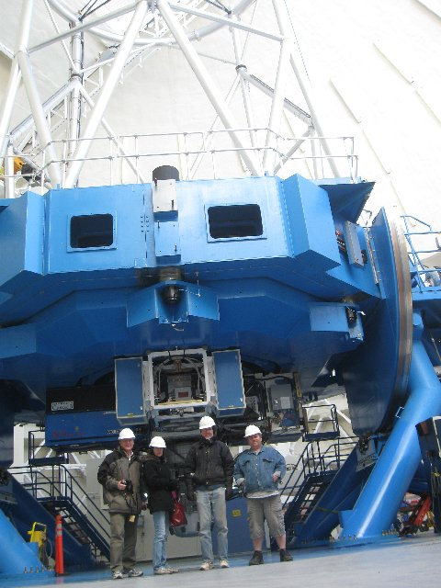

The bottom end of the telescope with a few humans for scale.

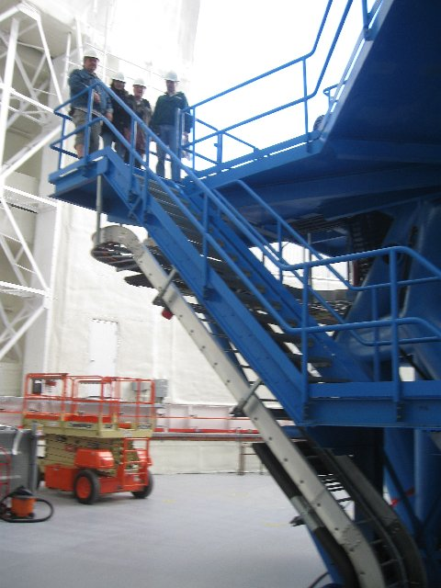

Climbing our way up to the mirror level.

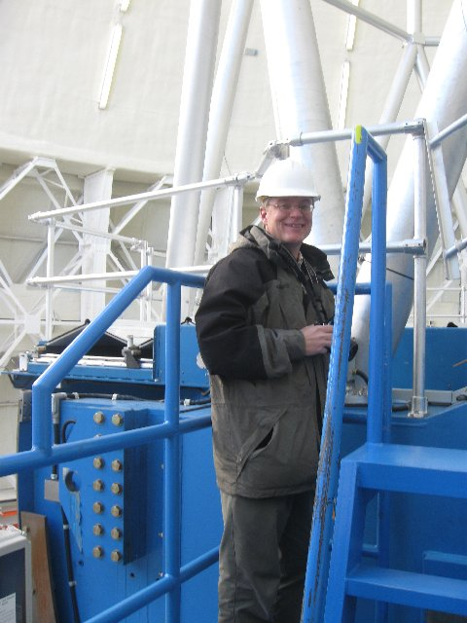

Bruce at the mirror level. Note the serious diameter steel truss tubes.

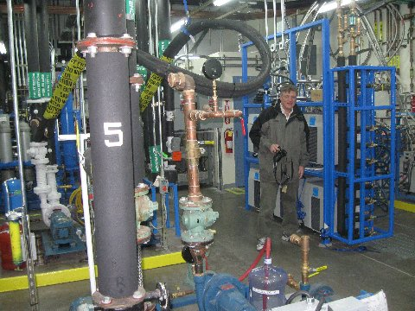

It takes a small forest of pumps to handle all the liquids used for cooling and various other purposes.

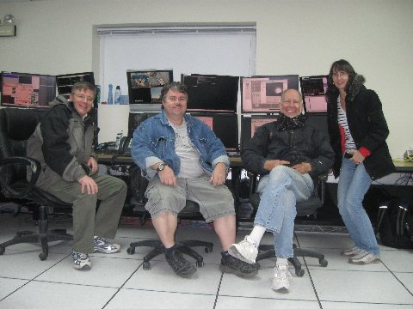

Now that we know how Gemini works, we are ready to take control of the telescope for the night!

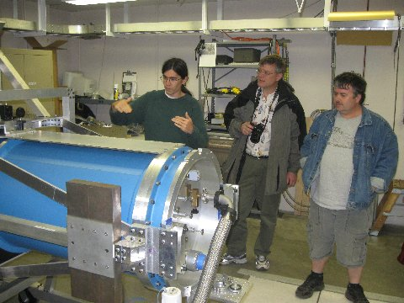

Instead we head over to the NASA Infrared Telescope Facility. Mike Connelley, left, describes the SOFIA instrument they are testing at IRFT prior to airborne flights.

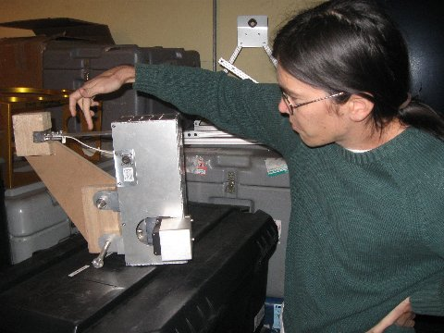

One of the reasons we were especially interested in IRFT was the chance to see and discuss primary mirror support systems with Mike. Here Mike shows us a mirror edge "warping" system they tried at IRFT. The wooden portion is just a temporary item and is not used when installed on the mirror. Some 8 of these were clamped around the edges of the mirror. Although they are not used now, Mike has something similar in mind for his own personal 1 meter telescope which has a very thin mirror.

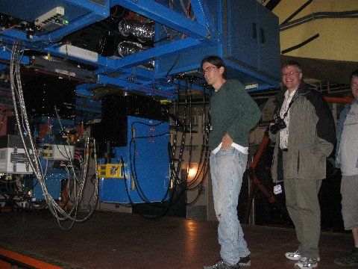

IRTF Cass focus instruments.

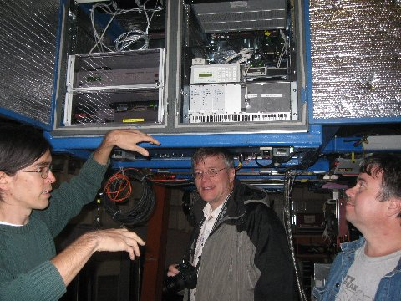

Mike explains the mirror support control system to Bruce and Chris. Part of the axial load is handled by three hard points, and part by some 16 air bags. Radial support is by mercury in a "tube."

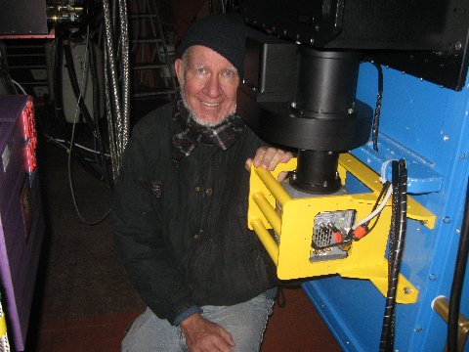

Russ beside the Andor emCCD camera and filter and optics for the POETS occultation group. Visual wavelength light is reflected off a dichroic mirror to this high speed, low read noise emCCD camera. This camera at the IRFT will be used for the two Pluto occultations this coming June. Russ recently submitted a grant request to the American Astronomical Society for a somewhat lower cost Andor emCCD camera for observing occultations and other high speed phenomena. Fingers are crossed!

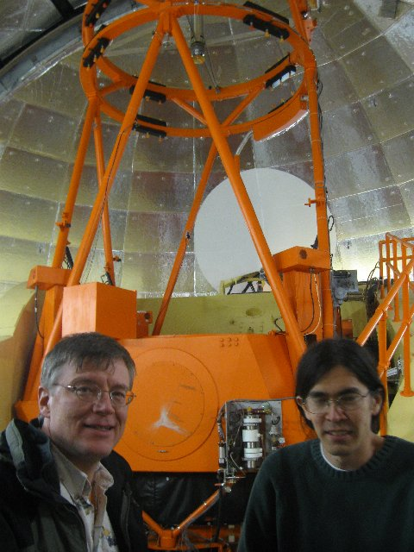

Bruce and Mike and the main portion of the IRFT telescope. Thanks Mike for a great tour!

